实验名称 单表查询2 专业 电子科学与技术 班级1701 姓名 潘陈昊 学号 31702513

实验目的：熟悉MySQL中的相关的选择、投影等相关简易查询语句

实验要求：

1、建立被查询的数据库

2、输入相关的查询语句并查看结果

实验过程：

USE LibraryManageSystem;

#LIMIT

SELECT *FROM ReaderType LIMIT 2;

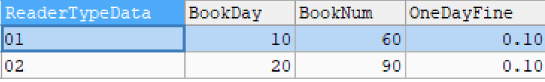

SELECT ReaderTypeData AS 用户类型,OneDayFine AS 调整前,OneDayFine*2 AS 调整后 FROM ReaderType ORDER BY 调整后 DESC LIMIT 2;

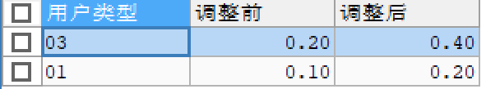

#select 用户类型,调整前,调整后 from ReaderType order by 调整后 desc limit 1 只有在同一个语句忠as后才能直接使用。

SELECT ReaderTypeData AS 用户类型,OneDayFine AS 调整前,OneDayFine*2 AS 调整后 FROM ReaderType ORDER BY 调整后 DESC LIMIT 1; #取出调整后单日罚金最高的

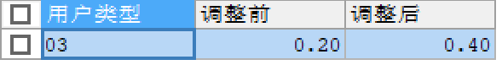

#多字段排序

SELECT * FROM ReaderType ORDER BY BookDay ,BookNum DESC;

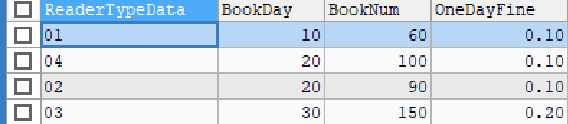

#汉字排序

SELECT * FROM ReaderInfo ORDER BY CONVERT(ReaderName USING gbk);



#模糊查询

SELECT * FROM ReaderInfo WHERE ReaderName LIKE "法外狂徒%";



SELECT * FROM ReaderInfo WHERE ReaderName LIKE "%三%";



SELECT * FROM ReaderInfo WHERE ReaderName LIKE "三_";



# %可以为空，_不可为空

#between.....and in

SELECT * FROM ReaderType WHERE BookNum BETWEEN 20 AND 100;

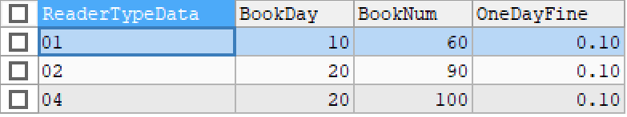

SELECT * FROM ReaderType WHERE BookNum IN(20,100);

